**=====CS673 Software Engineering** 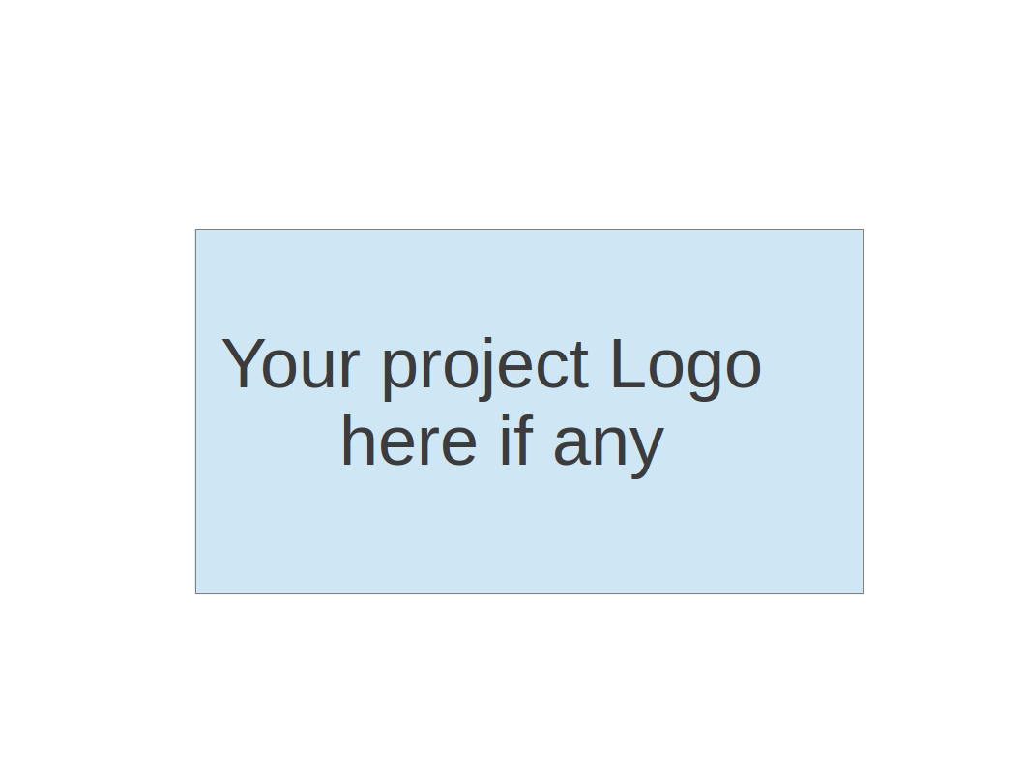

**Team X - Project Name**

**Tests Report**

|  |  |  |  |
| --- | --- | --- | --- |
| Team Member | Role(s) | Signature | Date |
|  |  |  |  |
|  |  |  |  |
|  |  |  |  |
|  |  |  |  |
|  |  |  |  |
|  |  |  |  |
|  |  |  |  |
|  |  |  |  |

**Revision history**

|  |  |  |  |
| --- | --- | --- | --- |
| **Version** | **Author** | **Date** | **Change** |
|  |  |  |  |
|  |  |  |  |

Introduction

Test Summary

Tests Reports

Testing Metrics

References

Glossary

# Introduction

In this section, give a summary of this tests report document.

# Test Summary

In this section, you will summarize what was tested and what happened, based on each test type.

* + Unit Tests
  + System Tests
  + Acceptance Tests

# Tests Reports

# In this section, you will give a detailed description of each test case performed and the result. You shall list what are existing tests developed in the previous semester and what are new tests developed currently.

For each test case, you can use the following template (or something based on the following template)

* Test case ID, name
* New or old:
* Test items: (what do you test )
* Test priority (high/medium/low)
* Dependencies (to other test case/requirement if any):
* Preconditions: (if any)
* input data:
* Test steps:
* Postconditions:
* Expected output:
* Actual output:
* Pass or Fail:
* Bug id/link: (this should link to your github issue id)
* Additional notes:

(You can use an additional table or document for this section)

# Testing Metrics

In this section, you shall report the any metrics used for the evaluation, e.g. coverage, defects rate, etc.

# References

# Glossary